# Design of Experiments Project

Author: Praveen Kumar Manoharan

Date: 28th June, 2025

Table of Contents

Design of Experiments Project 1

Introduction 2

DOE Tool (Desice.io) 2

Full Factorial Design 3

Fractional Factorial 3

Plackett-Burman 4

Bayesian optimization (Random statergy) 4

Desice.io Test cases 5

Test cases Generated by Plackett-Burman 5

Tests generated by Bayesian optimization (Random Strategy) 5

Gen AI – (Co-Pilot) Generated DOE cases: 6

Comparison of the test cases & conclusions 7

# Introduction

As part of this project, we consider a page with five different inputs, with two or more options as below listed are the inputs identified for testing.

|  |  |
| --- | --- |
| Input Type | Options (Levels) |
| Gender | Male, Female |
| Age Group | <18, 18-35, 36-60, >60 |
| Subscription Type | Free, Premium |
| Notification Pref. | Email, SMS, Push |
| Language | English, Spanish, French |

# DOE Tool (Desice.io)

For this project, I have selected to use [desice.io](https://www.desice.io/) cloud based DOE tool, to design and analysis my test executions and completions rates.

Desice is a powerful cloud and web-based DoE platform to evaluate the test approaches. It is good for engineers, R&D teams and scientist. It is designed for non-staticians, with an intuitive interfaces, quick tutorial and customer support. This tool supports Factorial designs, RSM, D-optimal, Bayesian optimization features. It is simple and easy to use with modern UI for analysis. This tool is still young, evolving for more advance niche statistical support.

As part of this tool, I have analyzed various different design experiments.

* Full Factorial Design
* Fractional Factorial
* Plackett-Burman
* Bayesian optimization (Random strategy)

This tool provides various design outputs for the data and also the effectiveness and test run order. This helps us to decide the best options for our test runs to be effective.

This tool provides easy to add & remove factors for the data set. It also provides options to creates multiple experiments and analyze experiments and data.

DoE based test cases provide a balanced, efficient way to test multi-input forms like the one in our project. This helps us to cover every possible combination, however this will may get some rare bugs.

## Full Factorial Design

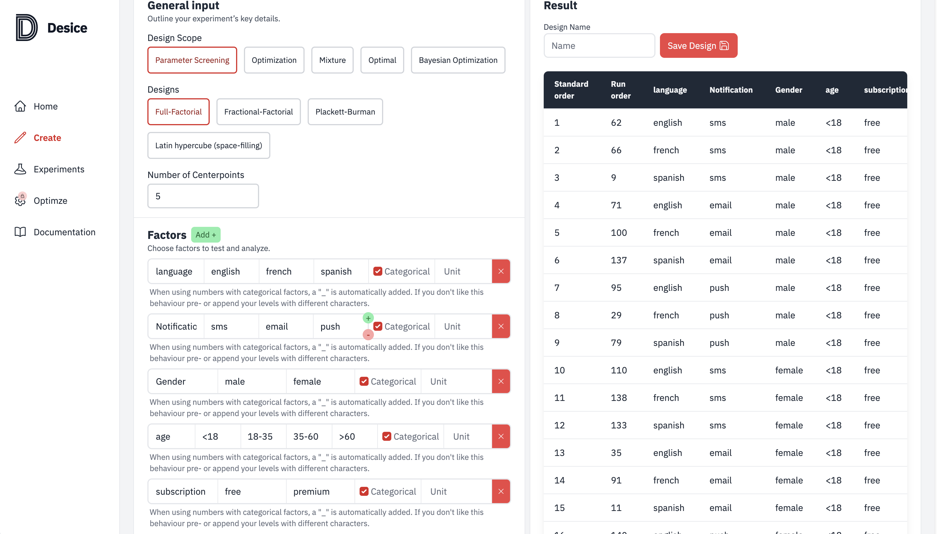

## Fractional Factorial

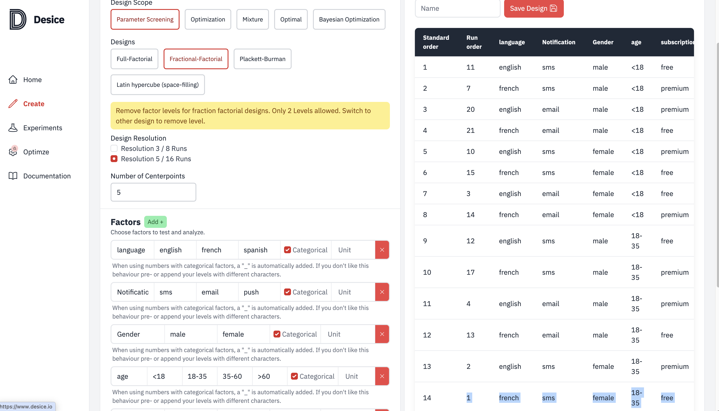

## Plackett-Burman

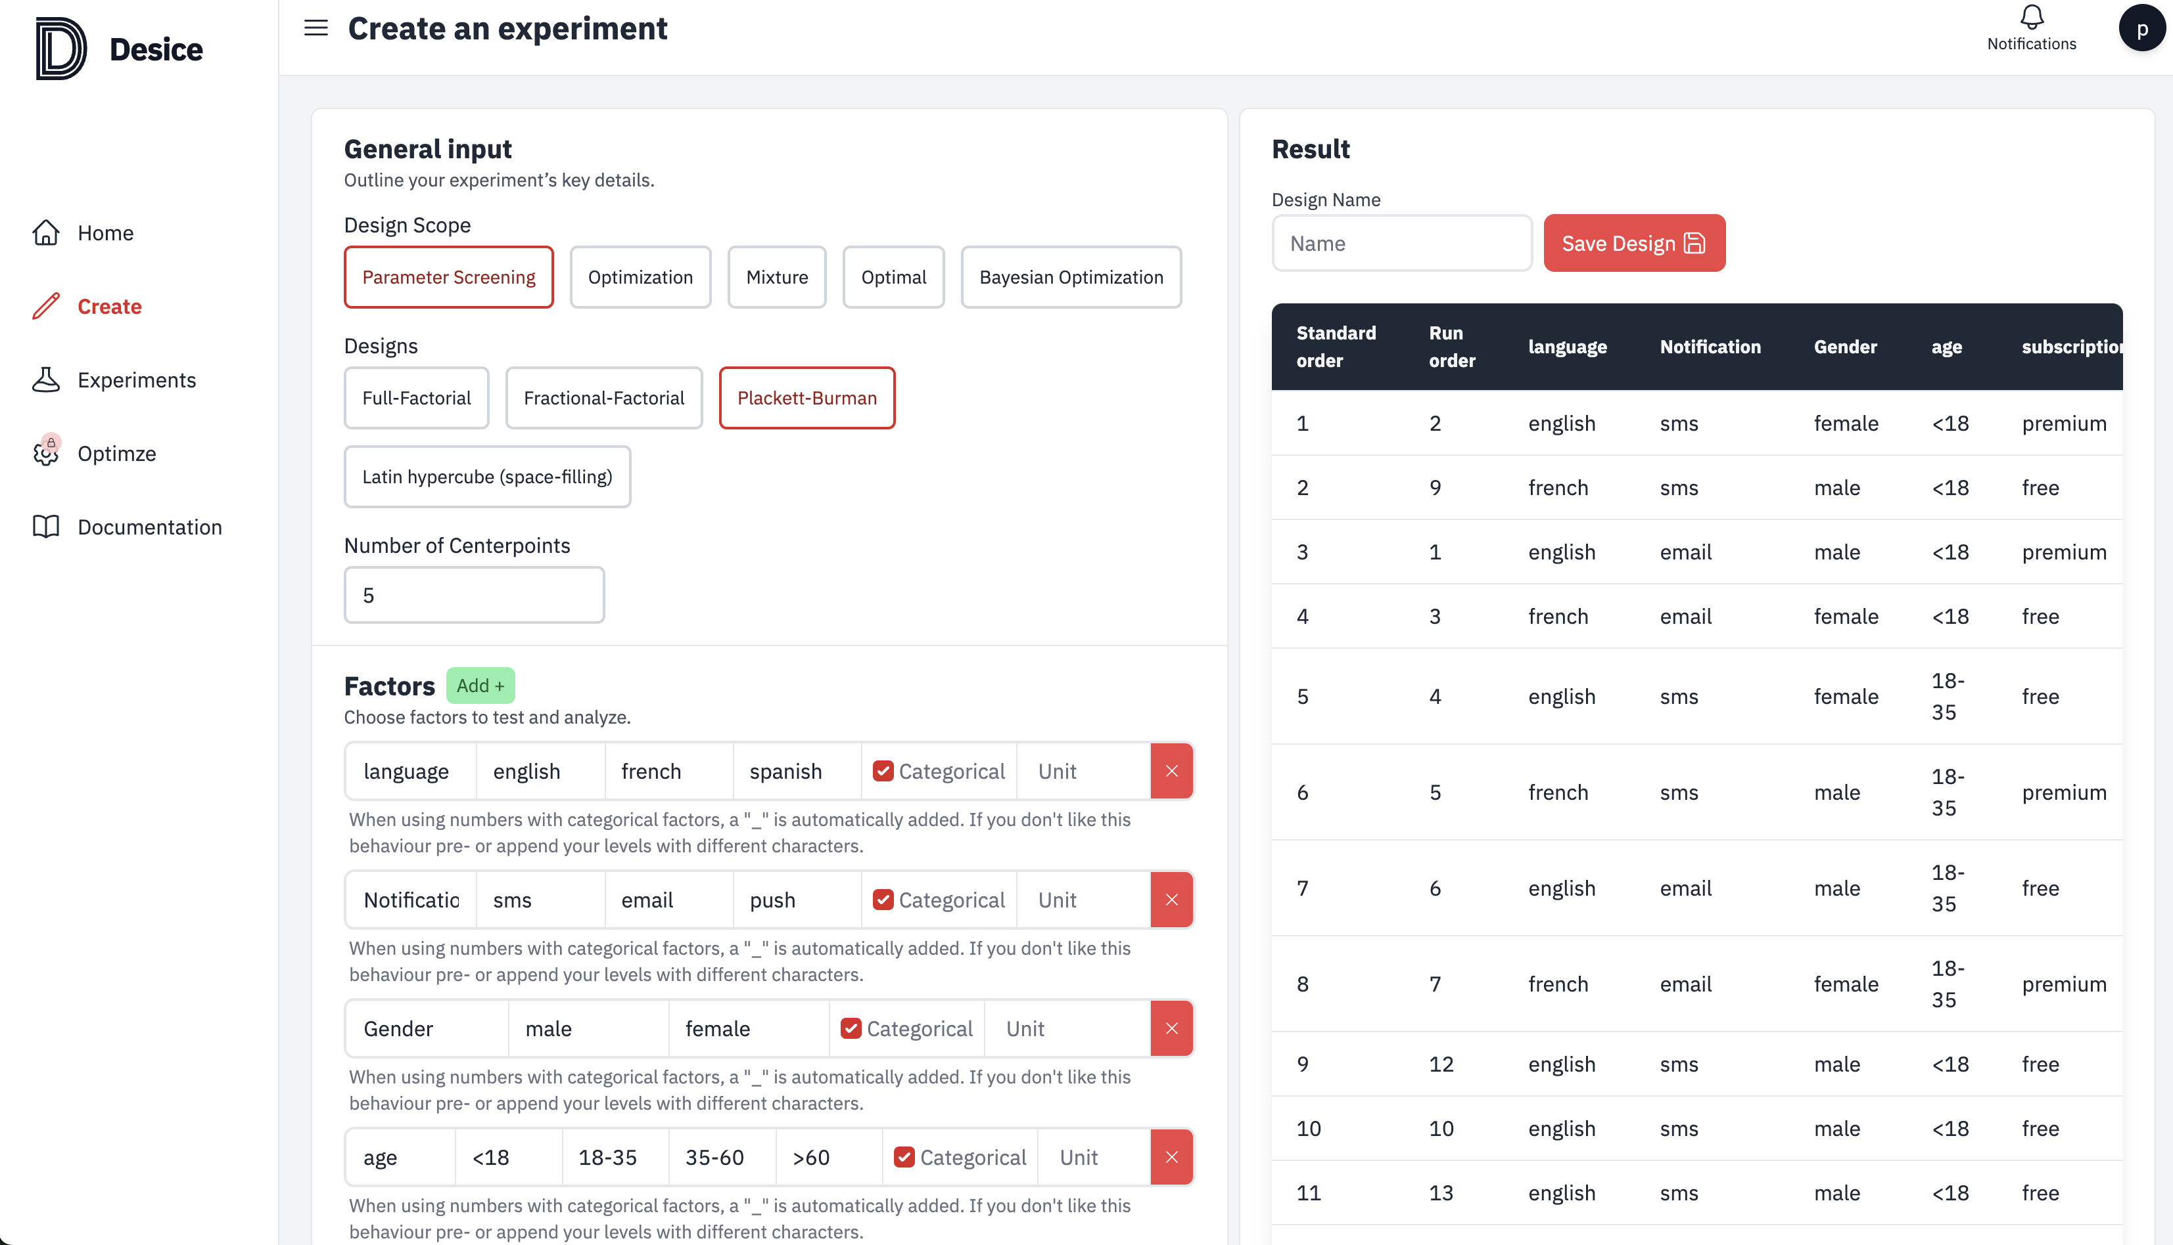

## Bayesian optimization (Random statergy)

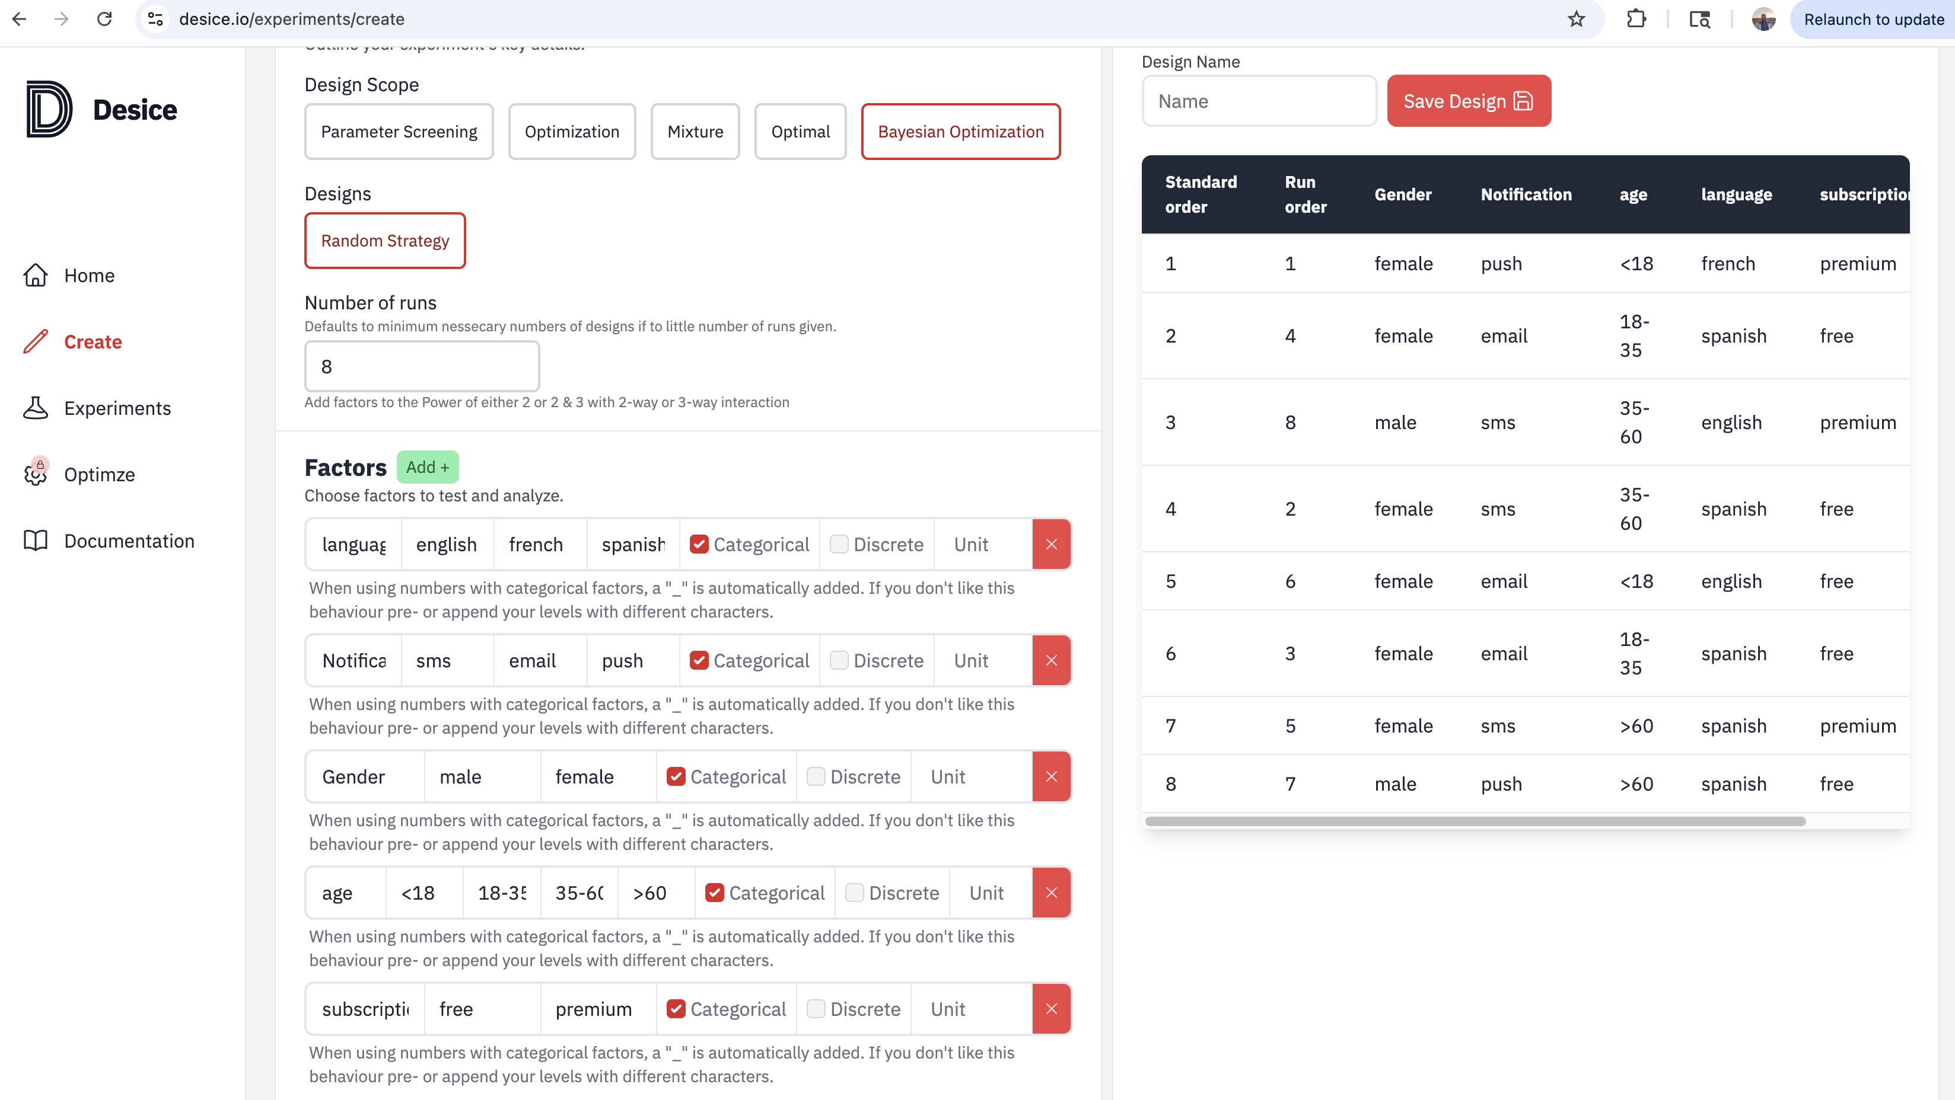

## Desice.io Test cases

### Test cases Generated by Plackett-Burman

Used Plackett-Burman, method to generate the DoE tool test cases. Tool has not generated maximum age variations in this test cases for us to use. However, on further analysis of the tool I was able to get maximum variations in test cases with next feature.

|  |  |  |  |  |  |  |  |
| --- | --- | --- | --- | --- | --- | --- | --- |
| Standard order | Run order | language | Notification | Gender | age | subscription | click |
| 1 | 2 | english | sms | female | <18 | premium | - |
| 2 | 9 | french | sms | male | <18 | free | - |
| 3 | 1 | english | email | male | <18 | premium | - |
| 4 | 3 | french | email | female | <18 | free | - |
| 5 | 4 | english | sms | female | 18-35 | free | - |
| 6 | 5 | french | sms | male | 18-35 | premium | - |
| 7 | 6 | english | email | male | 18-35 | free | - |
| 8 | 7 | french | email | female | 18-35 | premium | - |
| 9 | 12 | english | sms | male | <18 | free | - |
| 10 | 10 | english | sms | male | <18 | free | - |
| 11 | 13 | english | sms | male | <18 | free | - |
| 12 | 11 | english | sms | male | <18 | free | - |
| 13 | 8 | english | sms | male | <18 | free |  |

### Tests generated by Bayesian optimization (Random Strategy)

Below listed test cases has used pairwise execution of language + Gender + subscription + Notification and limited scope of age selection. As per the below test case they will help to test maximum input variations with limited test case.

In this test cases were created with minimum test cases for maximum test coverage with multiple input types.

| **Standard order** | **Run order** | **Gender** | **Notification** | **age** | **language** | **subscription** | **click** |
| --- | --- | --- | --- | --- | --- | --- | --- |
| 1 | 1 | female | push | <18 | french | premium | - |
| 2 | 4 | female | email | 18-35 | spanish | free | - |
| 3 | 8 | male | sms | 35-60 | english | premium | - |
| 4 | 2 | female | sms | 35-60 | spanish | free | - |
| 5 | 6 | female | email | <18 | english | free | - |
| 6 | 3 | female | email | 18-35 | spanish | free | - |
| 7 | 5 | female | sms | >60 | spanish | premium | - |
| 8 | 7 | male | push | >60 | spanish | free | - |

**Tool test case explanation**.

As per the tool the run order is defined to execute the test with minimum test cases for maximum coverage of the input test parameters.

**Test case 1**

Gender - user selects **female**

Notification – user select **push**

Age – user selects **<18**

Langague – user selects **French**

Subscription – user select **premium**

The test case should execute successfully saving the contents without any errors or exceptions.

Test case 2 –

Gender - user selects **female**

Notification – user select **push**

Age – user selects **<18**

Langague – user selects **French**

Subscription – user select **premium**

The test case should execute successfully saving the contents without any errors or exceptions.

Remaining above listed 8 tests should be executed in the Run order provided by the tool to effectively test and identify any bugs in the system.

This way we can validate the minimum test cases from better validation and identification of bugs. This will help us to validate the application effectively with limited time scope and effectively.

These executions still cannot identify all bugs available in the software.

# **Gen AI – (Co-Pilot) Generated DOE cases:**

DOE test matrix (Fractional Factorial Example). Testing all combinations (full factorial) would require 2 x 4 x 2 x 3 x3 = 144 tests. A fractional factorial design reduces the number of test while still covering interactions.

Here’s a sample test matrix (8 runs, Taguchi L8 orthogonal array):

|  |  |  |  |  |  |
| --- | --- | --- | --- | --- | --- |
| Test | Gender | Age Group | Subscription | Notification | Language |
| 1 | Male | <18 | Free | Email | English |
| 2 | Male | 18-35 | Premium | SMS | Spanish |
| 3 | Male | 36-60 | Free | Push | French |
| 4 | Male | >60 | Premium | Email | English |
| 5 | Female | <18 | Premium | SMS | French |
| 6 | Female | 18-35 | Free | Push | English |
| 7 | Female | 36-60 | Premium | Email | Spanish |
| 8 | Female | >60 | Free | SMS | French |

In this Gen AI generated test, which covers the Taguchi L8 orthogonal array, with all necessary variations to test cases.

In this test case of 8 we are validating the Gender, subscription, Notifications with maximum combination of Age and Language, to be the 3-way combinations to cover maximum validations with minimum test case.

**Test case 1**

Gender is Male

Age group of <18

Subscription type of Free

Notification Email

Language selected as English

The mobile app should accept these inputs, process them correctly, and behave as expected (e.g., save the data, show the correct summary, or proceed to the next step).

**Test case 2**

Gender selected is male

Age group of 18-35

Subscription type of Premium

Notification type as SMS

Language selected as Spanish

App should accept these inputs, process them correctly and behave as expected (eg. Save the data)

**Test case 3**

Gender selected is male

Age group of 36-60

Subscription type of Free

Notification type as Push

Language selected as French

App should accept these inputs and save them properly.

By executing the above 8 test cases in table, we can effectively test various combinations of inputs and check if the app can insert the data successfully and proceed to next step. As part of these test cases, we needed to make sure the app accepts the data without any errors, correct data is stored and displayed. Also make sure if any business validations or rules enforced correctly and executed.

# Comparison of the test cases & conclusions

In this section we compare the test case generated by Gen AI and the DoE tool (**Desice - Bayesian optimization (Random Strategy)).**

DoE allows us to test a wide range of input combinations with fewer test cases than exhaustive testing, save time and resources. The orthogonal array design helps uncover defects caused by integrations between different input factors. Also test cases are select scientifically, reducing bias and increasing the likelihood of finding edge-case buys.

As the comparsion the AI provided 8 major test cases to cover different inputs with minimum test cases. In case of the tool, the test case doesn’t cover all the major test as part of the placket-burman feature. However, the Bayesian optimization (random stragegy) test cases matched with the Co-pilot generated test case.

AI generated test cases with easy instruction about the data inputs for better test cases for maximum impact. In case of the tool, we needed to compare multiple strategies and features to generate the best suited tests cases for features.

DoE assumes that higher-order interactions, in this Gen AI and tool we have used 3-way interactions to get best output. The conclusion is these tools can help us arrive at maximum defect identification with limited test, with limitations to possible for rare buys which may be missed.

These test comparison between the Gen AI generated test cases and Tool generated test case both help us to check the mobile app works for a variety of realistic user input combination, increasing confidence in mobile app reliability.